## Razor Wire

**Razor barbed wire**, also known as razor barbed wire, blade gill nets, is a new type of protective net.Razor barbed wire is beautiful, economical and practical,the prevention effect is good, convenient construction and other outstanding features, present, blade barbed wire has been widely used in many countries in the industrial and mining enterprises, garden apartments, border posts, military field, prisons, detention centers, government buildings and other national security facilities.

**Razor Barbed Wire Advantages:**    
**1)** High security  
Barbed razor wire with the sharp razor guarantees a high security whilst retaining high quality.

**2)** Long life  
Razor wire material of stainless steel or hot-galvanized makes sure for long life and low maintenance.

**3)** Easy installation  
Short sections needed for urgent security can be installed extremely fast and with little equipment, allowing repairs to be carried out without compromising perimeter security.

**Razor Barbed Wire Application:**mainly used for garden apartments, organs and units, prisons, post, border protection ring ban.

**Razor Barbed Wire Process:** blade gill nets made of galvanized steel sheet or stainless steel sheet metal stamping out the sharp blade-like, high strength galvanized steel wire or stainless steel wire to do a combination of denial-of-core line equipment.Since gill nets difficult to shape a unique touch, which can achieve excellent effects of protective isolation.

**Assortment:**Stainless steel razor barbed wire,   
Electric galvanized razor barbed wire,   
Hot dipped galvanized razor barbed wire.

**Specifications:**

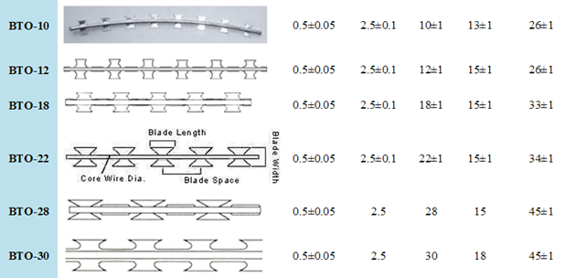

|  |  |  |  |  |
| --- | --- | --- | --- | --- |
| **Razor Barbed Wire** | | | | |
| Loop Outside Diameter | No. of Loops | Standard Length per Coil | Type | Notes |
| 450mm | 56 | 8-9m(3 CLIPS) | BTO-10.12.18.22.28.30 | Cross type |
| 500mm | 56 | 9-10M (3 CLIPS) | BTO-10.12.18.22.28.30 | Cross type |
| 600mm | 56 | 10-11M(3 CLIPS) | BTO-10.12.18.22.28.30 | Cross type |
| 600mm | 56 | 8-10M (5 CLIPS) | BTO-10.12.18.22.28.30 | Cross type |
| 700mm | 56 | 10-12M (5 CLIPS) | BTO-10.12.18.22.28.30 | Cross type |
| 800mm | 56 | 11-13M (5 CLIPS) | BTO-10.12.18.22.28.30 | Cross type |
| 900mm | 56 | 12-14M (5 CLIPS) | BTO-10.12.18.22.28.30 | Cross type |
| 960mm | 56 | 13-15M (5 CLIPS) | BTO-10.12.18.22.28.30 | Cross type |
| 980mm | 56 | 14-16M (5 CLIPS) | BTO-10.12.18.22.28.30 | Cross type |